
https://saekagdim.gr/

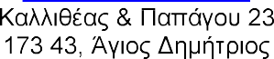
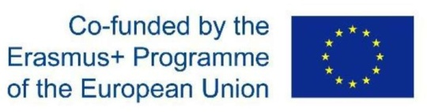
+30210976 3259
iekagdim.mobility@gmail.com

«EmpoweringthroughMobility» 2025-1-EL01-KA122-VET-000332386

ERASMUS+ 2025
«EmpoweringthroughMobility»
.

Eco-Education &ActiveCitizenship in early childhood
.
.

«Empoweringthrough Mobility» Eco-Education & Active Citizenship in early childhood
- 2 Α&

- 2026-2026

.

iekagdim.mobility@gmail.com

mail

-


Eco- Education&ActiveCitizenshipinearlychildhood

/
Mobility»
«Empowering through

-

A.

:

- (mail)

:
A(
): 6.

-MAIL


https://saekagdim.gr/

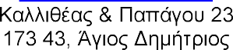
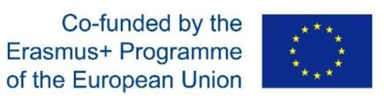
+30210976 3259
iekagdim.mobility@gmail.com

«EmpoweringthroughMobility» 2025-1-EL01-KA122-VET-000332386

:

/

;

